|  |
| --- |
| **DIGITAL SYSTEM DESIGN LABORATORY** |
| **LAB 2** |

**IMPLEMENTATION OF COMBINATION LOGIC CIRCUIT (PART 2) USING VERILOG IN FPGA KIT**

### I. LAB OBJECTIVES

### This Lab experiments are intended to implement Combination Logic Circuits in Verilog. Students are require to write test bench to simulate the given example code and Top level module to implement these codes in DE2-115 FPGA Kit.

### II. LAB EXPERIMENT EXERCISES

**AIM: WRITE VERILOG HDL CODES TO SIMULATE AND IMPLEMENT THE FOLLOWING DIGITAL SEQUENTIAL LOGIC CIRCUITS:**

**1) Multiplexer 8 to 1**

**Logic circuit**

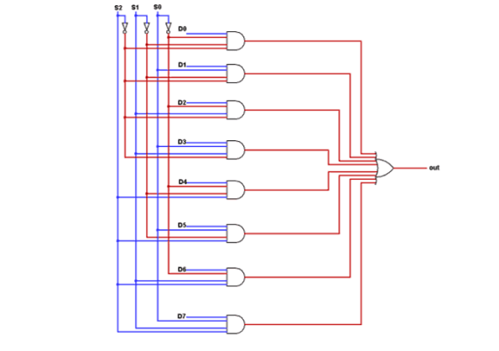

**Truth table**

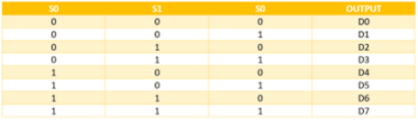

|  |  |  |
| --- | --- | --- |
| **Top module** | | |
| module lab2_ex1(SW,LEDG,LEDR);  input[17:0]SW;  output[7:0] LEDG;  output[17:0] LEDR;    assign LEDR = SW;    //m81_GL(.d(SW[11:4]),.s(SW[2:0]),.out(LEDG[7]));  //m81_DF(.d(SW[11:4]),.s(SW[2:0]),.out(LEDG[7]));  m81_BEH(.d(SW[11:4]),.s(SW[2:0]),.out(LEDG[7]));  endmodule | | |
| **Structural** | **Dataflow** | **Behavior** |
| module m81_GL(d,s,out);  input [7:0] d;  input [2:0] s;  output out;  wire [10:0] t;  not(t[0], s[0]);  not(t[1], s[1]);  not(t[2], s[2]);  and(t[3], d[0], t[0], t[1], t[2]), (t[4], d[1],s[0], t[1], t[2]);  and(t[5], d[2], t[0], s[1], t[2]), (t[6], d[3], s[0], s[1], t[2]);  and(t[7], d[4], t[0], t[1], s[2]), (t[8], d[5], s[0], t[1], s[2]);  and(t[9], d[6], t[0], s[1], s[2]), (t[10], d[7], s[0], s[1], s[2]);  or(out, t[3], t[4], t[5], t[6], t[7],t[8], t[9], t[10]);  endmodule | module m81_DF(d,s,out);  input [7:0] d;  input [2:0] s;  wire [2:0] n_s;  output out;  assign n_s[0]=~s[0];  assign n_s[1]=~s[1];  assign n_s[2]=~s[2];  assign out = (d[0] & n_s[2] & n_s[1] & n_s[0]) | (d[1] & n_s[2] & n_s[1] & s[0]) | (d[2] & n_s[2] & s[1] & n_s[0]) + (d[3] & n_s[2] & s[1] & s[0]) + (d[4] & s[2] & n_s[1] & n_s[0]) + (d[5] & s[2] & n_s[1] & s[0]) + (d[6] & s[2] & s[1] & n_s[0]) + (d[7] & s[2] & s[1] & s[0]);  endmodule | module m81_BEH(d,s,out);  input [7:0] d;  input [2:0] s;  output reg out;  always@(*) begin  case(s)  3'b000: out=d[0];  3'b001: out=d[1];  3'b010: out=d[2];  3'b011: out=d[3];  3'b100: out=d[4];  3'b101: out=d[5];  3'b110: out=d[6];  3'b111: out=d[7];  default: out=1'b0;  endcase  end  endmodule |
| **Testbench** | | |
| module tb_m81;  reg [7:0] d;  reg [2:0] s;  wire out;  m81_BEH uut (  .d(d),  .s(s),  .out(out)  );  initial begin  d = 8'b00000000;  s = 3'b000;  d = 8'b10101010;  #10 s = 3'b000;  #10 s = 3'b001;  #10 s = 3'b010;  #10 s = 3'b011;  #10 s = 3'b100;  #10 s = 3'b101;  #10 s = 3'b110;  #10 s = 3'b111;  #10 $finish;  end  initial begin  $monitor("Time = %t | d = %b | s = %b | out = %b", $time, d, s, out);  end  endmodule | | |
|  | | |
|  | | |

2) 1:8 Demultiplexer

**Logic circuit**

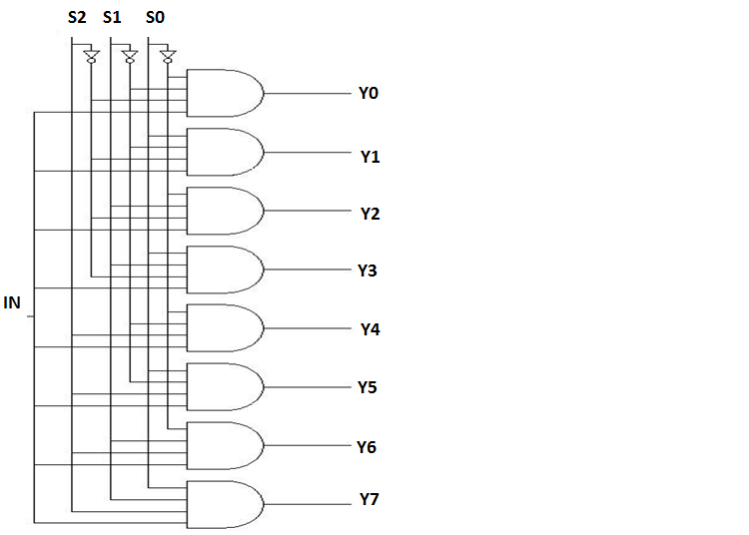

**Truth table**

|  |  |  |  |  |  |  |  |  |  |  |
| --- | --- | --- | --- | --- | --- | --- | --- | --- | --- | --- |
| **S2** | **S1** | **S0** | **Y7** | **Y6** | **Y5** | **Y4** | **Y3** | **Y2** | **Y1** | **Y0** |
| 0 | 0 | 0 | 0 | 0 | 0 | 0 | 0 | 0 | 0 | IN |
| 0 | 0 | 1 | 0 | 0 | 0 | 0 | 0 | 0 | IN | 0 |
| 0 | 1 | 0 | 0 | 0 | 0 | 0 | 0 | IN | 0 | 0 |
| 0 | 1 | 1 | 0 | 0 | 0 | 0 | IN | 0 | 0 | 0 |
| 1 | 0 | 0 | 0 | 0 | 0 | IN | 0 | 0 | 0 | 0 |
| 1 | 0 | 1 | 0 | 0 | IN | 0 | 0 | 0 | 0 | 0 |
| 1 | 1 | 0 | 0 | IN | 0 | 0 | 0 | 0 | 0 | 0 |
| 1 | 1 | 1 | IN | 0 | 0 | 0 | 0 | 0 | 0 | 0 |

|  |  |  |
| --- | --- | --- |
| **Top module** | | |
| module lab2_ex2(SW,LEDG,LEDR);  input[17:0]SW;  output[7:0] LEDG;  output[17:0] LEDR;    assign LEDR = SW;    //demux18_GL(.a(SW[4]),.s(SW[2:0]),.y(LEDG[7:0]));  //demux18_DF(.a(SW[4]),.s(SW[2:0]),.y(LEDG[7:0]));  demux18_BH(.a(SW[4]),.s(SW[2:0]),.y(LEDG[7:0]));  endmodule | | |
| **Structural** | **Dataflow** | **Behavior** |
| module demul18_GL(a,s,y);  input a;  input [2:0]s;  output[7:0]y;    wire [2:0] n_s;  not (n_s[0], s[0]);  not (n_s[1], s[1]);  not (n_s[2], s[2]);  and (y[0], a, n_s[2], n_s[1], n_s[0]);  and (y[1], a, n_s[2], n_s[1], s[0]);  and (y[2], a, n_s[2], s[1], n_s[0]);  and (y[3], a, n_s[2], s[1], s[0]);  and (y[4], a, s[2], n_s[1], n_s[0]);  and (y[5], a, s[2], n_s[1], s[0]);  and (y[6], a, s[2], s[1], n_s[0]);  and (y[7], a, s[2], s[1], s[0]);  endmodule | module Demultiplexer_1_to_8_assign(output [7:0] Y, input [2:0] A, input din);  assign Y[0] = din & (~A[0]) & (~A[1]) & (~A[2]);  assign Y[1] = din & (~A[1]) & A[0] & (~A[2]);  assign Y[2] = din & A[1] & (~A[0]) & (~A[2]);  assign Y[3] = din & A[1] & A[0] & (~A[2]);  assign Y[4] = din & (~A[0]) & (~A[1]) & (A[2]);  assign Y[5] = din & (~A[1]) & A[0] & (A[2]);  assign Y[6] = din & A[1] & (~A[0]) & (A[2]);  assign Y[7] = din & A[1] & A[0] & (A[2]);  endmodule | module demux18_BH(a,s,y);  input a;  input [2:0]s;  output reg [7:0]y;    always @(*) begin  y[0] = (s == 3'b000) ? a : 1'b0;  y[1] = (s == 3'b001) ? a : 1'b0;  y[2] = (s == 3'b010) ? a : 1'b0;  y[3] = (s == 3'b011) ? a : 1'b0;  y[4] = (s == 3'b100) ? a : 1'b0;  y[5] = (s == 3'b101) ? a : 1'b0;  y[6] = (s == 3'b110) ? a : 1'b0;  y[7] = (s == 3'b111) ? a : 1'b0;  end  endmodule |
| Testbench | | |
| module demux_18_tb;  wire [7:0] y;  reg a;  reg [2:0] s;  demul18_GL dut (a, s, y);  initial begin  a = 1'b0;  s = 3'b000;  #100 a = 1'b1;  #800 $finish;  end  initial begin  $monitor("Time = %0t | a = %b | s = %b | y = %b", $time, a, s, y);  end  always #100 s[0] = ~s[0];  always #200 s[1] = ~s[1];  always #400 s[2] = ~s[2];  endmodule | | |
|  | | |
|  | | |

**3) 4-to-2 bit Encoder**

**Logic circuit**

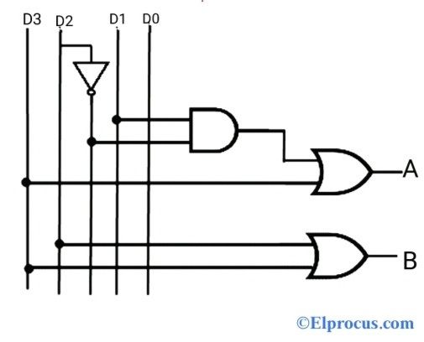

**Truth table**

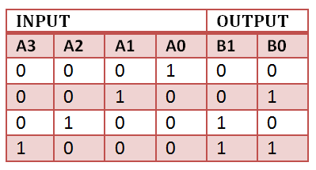

|  |  |  |
| --- | --- | --- |
| **Top module** | | |
| module lab2_ex3(SW,LEDG,LEDR);  input[17:0]SW;  output[7:0] LEDG;  output[17:0] LEDR;    assign LEDR = SW;    //encoder42_GL(.a(SW[3:0]),.y(LEDG[7:6]));  //encoder42_DF(.a(SW[3:0]),.y(LEDG[7:6]));  encoder42_BH(.a(SW[3:0]),.y(LEDG[7:6]));  endmodule | | |
| **Structural** | **Dataflow** | **Behavior** |
| module encoder42_GL(a,y);  input [3:0]a;  output [1:0]y;  wire n_a2,w;    not (n_a2, a[2]);  and (w, n_a2,a[1]);  or (y[0], w, a[3]);  or (y[1], a[2], a[3]);  endmodule | module encoder42_DF(a,y);  input [3:0]a;  output [1:0]y;    assign y[0] = a[1] | a[3];  assign y[1] = a[2] | a[3];  endmodule | module encoder42_BH(a,y);  input [3:0]a;  output reg [1:0]y;  always @(*) begin  case (1'b1)  a[3]: y = 2'b11;  a[2]: y = 2'b10;  a[1]: y = 2'b01;  a[0]: y = 2'b00;  default: y = 2'b00;  endcase  end  endmodule |
| **Testbench** | | |
| module tb_encoder42;  reg [3:0]a;  wire [1:0]y;    encoder42_GL dut(a,y);    initial begin  a=4'b0000;    $monitor("Time: %0t,a = %b,y = %b",$time,a,y);  #10 a=4'b0001;  #10 a=4'b0010;  #10 a=4'b0100;  #10 a=4'b1000;    $finish;  end  endmodule | | |
|  | | |
|  | | |

**4) 2-to-4 Binary Decoders**

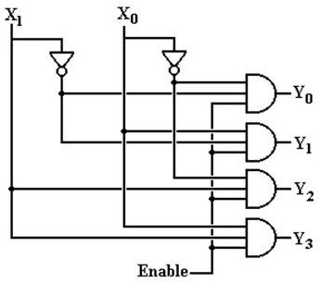

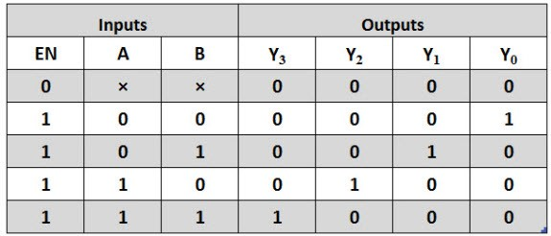

|  |  |  |
| --- | --- | --- |
| **Top module** | | |
| module lab2_ex4(SW,LEDG,LEDR);  input[17:0]SW;  output[7:0] LEDG;  output[17:0] LEDR;    assign LEDR = SW;    //decoder24_BH(.e(SW[2]),.x(SW[1:0]),.y(LEDG[7:4]));  //decoder24_DF(.e(SW[2]),.x(SW[1:0]),.y(LEDG[7:4]));  decoder24_GL(.e(SW[2]),.x(SW[1:0]),.y(LEDG[7:4]));  endmodule | | |
| **Structural** | **Dataflow** | **Behavior** |
| module decoder24_GL(e, x, y);  input e;  input [1:0] x;  output [3:0] y;    wire [1:0] nx;    not g1(nx[0], x[0]);  not g2(nx[1], x[1]);    and g3(y[0], nx[0], nx[1], e);  and g4(y[1], x[0], nx[1], e);  and g5(y[2], nx[0], x[1], e);  and g6(y[3], x[0], x[1], e);  endmodule | module decoder24_DF(e, x, y);  input e;  input [1:0] x;  output [3:0] y;  assign y[0] = ~x[0] & ~x[1] & e;  assign y[1] = x[0] & ~x[1] & e;  assign y[2] = ~x[0] & x[1] & e;  assign y[3] = x[0] & x[1] & e;  endmodule | module decoder24_BH(e, x, y);  input e;  input [1:0] x;  output reg [3:0] y;  always @(*) begin  if (e) begin  case (x)  2'b00: y <= 4'b0001;  2'b01: y <= 4'b0010;  2'b10: y <= 4'b0100;  2'b11: y <= 4'b1000;  default: y <= 4'b0000;  endcase  end else begin  y <= 4'b0000;  end  end  endmodule |
| **Testbench** | | |
| module decoder24_testbench;  reg e;  reg [1:0] x;  wire [3:0] y_GL, y_DF, y_BEH;  decoder24_GL gate_level_decoder (.e(e), .x(x), .y(y_GL));  decoder24_DF dataflow_decoder (.e(e), .x(x), .y(y_DF));  decoder24_BH behavioral_decoder (.e(e), .x(x), .y(y_BEH));  initial begin  $monitor("Time = %0d | e = %b | x = %b | GL = %b | DF = %b | BEH = %b",  $time, e, x, y_GL, y_DF, y_BEH);  e = 1; x = 2'b00; #10;  e = 1; x = 2'b01; #10;  e = 1; x = 2'b10; #10;  e = 1; x = 2'b11; #10;  e = 0; x = 2'b00; #10;  e = 0; x = 2'b11; #10;  $finish;  end  endmodule | | |
|  | | |
|  | | |

**5) 8:3 Encoder**

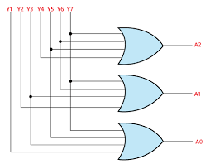

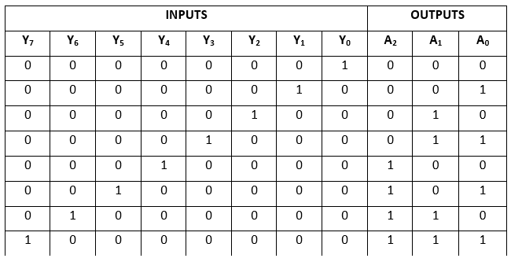

|  |  |  |
| --- | --- | --- |
| **Top module** | | |
| module lab2_ex5(SW,LEDG,LEDR);  input[17:0]SW;  output[7:0] LEDG;  output[17:0] LEDR;    assign LEDR = SW;    //encoder83_DF(.a(SW[7:0]),.y(LEDG[7:5]));  //encoder83_BH(.a(SW[7:0]),.y(LEDG[7:5]));  encoder83_GL(.a(SW[7:0]),.y(LEDG[7:5]));    endmodule | | |
| **Structural** | **Dataflow** | **Behavior** |
| module encoder83_GL(a,y);  input [7:0] a;  output [2:0] y;    or g1(y[0],a[1],a[3],a[5],a[7]);  or g2(y[1],a[2],a[3],a[6],a[7]);  or g3(y[2],a[4],a[5],a[6],a[7]);  endmodule | module encoder83_DF(a, y);  input [7:0] a;  output [2:0] y;  assign y[0] = a[1] | a[3] | a[5] | a[7];  assign y[1] = a[2] | a[3] | a[6] | a[7];  assign y[2] = a[4] | a[5] | a[6] | a[7];  endmodule | module encoder83_BH(a, y);  input [7:0] a;  output reg [2:0] y;  always @(*) begin  if (a[7]) y <= 3'b111;  else if (a[6]) y <= 3'b110;  else if (a[5]) y <= 3'b101;  else if (a[4]) y <= 3'b100;  else if (a[3]) y <= 3'b011;  else if (a[2]) y <= 3'b010;  else if (a[1]) y <= 3'b001;  else y <= 3'b000;  end  endmodule |
| **Testbench** | | |
| module encoder83_testbench;  reg [7:0] a;  wire [2:0] y_GL, y_DF, y_BEH;  encoder83_GL gl_encoder (.a(a), .y(y_GL));  encoder83_DF df_encoder (.a(a), .y(y_DF));  encoder83_BH beh_encoder (.a(a), .y(y_BEH));  initial begin  $monitor("Time = %0d | a = %b | GL = %b | DF = %b | BEH = %b",  $time, a, y_GL, y_DF, y_BEH);  a = 8'b00000000; #10;  a = 8'b10000000; #10;  a = 8'b01000000; #10;  a = 8'b00100000; #10;  a = 8'b00010000; #10;  a = 8'b00001000; #10;  a = 8'b00000100; #10;  a = 8'b00000010; #10;  a = 8'b00000001; #10;  $finish;  end  endmodule | | |
|  | | |
|  | | |

**6) 3:8 Decoder**

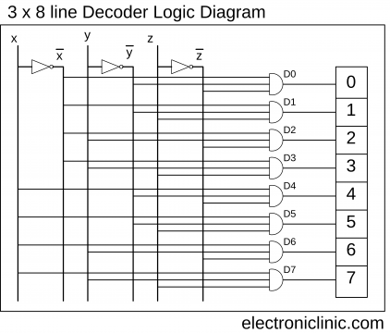

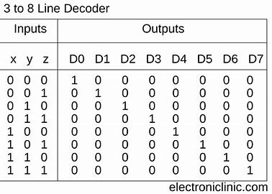

|  |  |  |
| --- | --- | --- |
| **Top module** | | |
| module lab2_ex6(SW,LEDG,LEDR);  input[17:0]SW;  output[7:0] LEDG;  output[17:0] LEDR;    assign LEDR = SW;    dec38_GL(.a(SW[2:0]),.d(LEDG[7:0]));  //dec38_DF(.a(SW[2:0]),.d(LEDG[7:0]));  //dec38_BH(.a(SW[2:0]),.d(LEDG[7:0]));    endmodule | | |
| **Structural** | **Dataflow** | **Behavior** |
| module dec38_GL(a,d);  input [2:0] a;  output [7:0] d;  wire [2:0] n_a;  not g1(n_a[0],a[0]);  not g2(n_a[1],a[1]);  not g3(n_a[2],a[2]);    and g4(d[0], n_a[2], n_a[1], n_a[0]);  and g5(d[1], n_a[2], n_a[1], a[0]);  and g6(d[2], n_a[2], a[1], n_a[0]);  and g7(d[3], n_a[2], a[1], a[0]);  and g8(d[4], a[2], n_a[1], n_a[0]);  and g9(d[5], a[2], n_a[1], a[0]);  and g10(d[6], a[2], a[1], n_a[0]);  and g11(d[7], a[2], a[1], a[0]);  endmodule | module dec38_DF(a, d);  input [2:0] a;  output [7:0] d;  assign d[0] = ~a[2] & ~a[1] & ~a[0];  assign d[1] = ~a[2] & ~a[1] & a[0];  assign d[2] = ~a[2] & a[1] & ~a[0];  assign d[3] = ~a[2] & a[1] & a[0];  assign d[4] = a[2] & ~a[1] & ~a[0];  assign d[5] = a[2] & ~a[1] & a[0];  assign d[6] = a[2] & a[1] & ~a[0];  assign d[7] = a[2] & a[1] & a[0];  endmodule | module dec38_BH(a,d);  input [2:0] a;  output reg [7:0] d;  always @( a )  begin  d=8'd0;  case (a)  3'b000: d[0]=1'b1;  3'b001: d[1]=1'b1;  3'b010: d[2]=1'b1;  3'b011: d[3]=1'b1;  3'b100: d[4]=1'b1;  3'b101: d[5]=1'b1;  3'b110: d[6]=1'b1;  3'b111: d[7]=1'b1;  default: d=8'd0;  endcase  end  endmodule |
| **Testbench** | | |
| module dec38_testbench;  reg [2:0] a;  wire [7:0] d_GL, d_DF, d_BEH;  dec38_GL gl_decoder (.a(a), .d(d_GL));  dec38_DF df_decoder (.a(a), .d(d_DF));  dec38_BH beh_decoder (.a(a), .d(d_BEH));  initial begin  $monitor("Time = %0d | a = %b | GL = %b | DF = %b | BEH = %b",  $time, a, d_GL, d_DF, d_BEH);  a = 3'b000; #10;  a = 3'b001; #10;  a = 3'b010; #10;  a = 3'b011; #10;  a = 3'b100; #10;  a = 3'b101; #10;  a = 3'b110; #10;  a = 3'b111; #10;  $finish;  end  endmodule | | |
|  | | |
|  | | |

**7) 4 Bit Comparator**

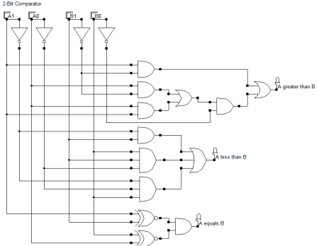

|  |  |  |  |  |  |  |
| --- | --- | --- | --- | --- | --- | --- |
| **A3B3** | **A2B2** | **A1B1** | **A0B0** | **A>B** | **A<B** | **A=B** |
| A3>B3 | x | x | x | 1 | 0 | 0 |
| A3<B3 | x | x | x | 0 | 1 | 0 |
| A3=B3 | A2>B2 | x | x | 1 | 0 | 0 |
| A3=B3 | A2<B2 | x | x | 0 | 1 | 0 |
| A3=B3 | A2=B2 | A1>B1 | x | 1 | 0 | 0 |
| A3=B3 | A2=B2 | A1<B1 | x | 0 | 1 | 0 |
| A3=B3 | A2=B2 | A1=B1 | A0>B0 | 1 | 0 | 0 |
| A3=B3 | A2=B2 | A1=B1 | A0<B0 | 0 | 1 | 0 |
| A3=B3 | A2=B2 | A1=B1 | A0=B0 | 0 | 0 | 1 |

|  |  |  |
| --- | --- | --- |
| **Top module** | | |
| module lab2_ex7(SW,LEDG,LEDR);  input[17:0]SW;  output[7:0] LEDG;  output[17:0] LEDR;    assign LEDR = SW;    comp4bit_GL(.a(SW[7:4]),.b(SW[3:0]),.d(LEDG[7:5]));  //comp4bit_DF(.a(SW[7:4]),.b(SW[3:0]),.d(LEDG[7:5]));  //comp4bit_BH(.a(SW[7:4]),.b(SW[3:0]),.d(LEDG[7:5]));  endmodule | | |
| **Structural** | **Dataflow** | **Behavior** |
| module comp4bit_GL(a,b,d);  input [3:0]a;  input [3:0]b;  output [2:0]d;  wire [7:0]y;    wire [3:0] n_a;  wire [3:0] n_b;  wire [3:0] w;    not g1_0(n_a[0], a[0]);  not g1_1(n_a[1], a[1]);  not g1_2(n_a[2], a[2]);  not g1_3(n_a[3], a[3]);  not g2_0(n_b[0], b[0]);  not g2_1(n_b[1], b[1]);  not g2_2(n_b[2], b[2]);  not g2_3(n_b[3], b[3]);    xnor g3(w[3],a[3],b[3]);  xnor g4(w[2],a[2],b[2]);  xnor g5(w[1],a[1],b[1]);  xnor g6(w[0],a[0],b[0]);    and g7(d[0],w[0],w[1],w[2],w[3]);  and g8(y[0],n_a[3],b[3]);  and g9(y[1],n_a[2],b[2],w[3]);  and g10(y[2],n_a[1],b[1],w[3],w[2]);  and g11(y[3],n_a[0],b[0],w[3],w[2],w[1]);    and g12(y[4],a[3],n_b[3]);  and g13(y[5],a[2],n_b[2],w[3]);  and g14(y[6],a[1],n_b[1],w[3],w[2]);  and g15(y[7],a[0],n_b[0],w[3],w[2],w[1]);    or g16(d[1],y[0],y[1],y[2],y[3]);  or g17(d[2],y[4],y[5],y[6],y[7]);  endmodule | module comp4bit_DF (a, b, d);  input [3:0] a;  input [3:0] b;  output [2:0] d;  assign d[0] = ~(a[3] ^ b[3]) & ~(a[2] ^ b[2]) & ~(a[1] ^ b[1]) & ~(a[0] ^ b[0]);  assign d[1] = (a[3] & ~b[3]) | (a[2] & ~b[2] & ~(a[3] ^ b[3])) | (a[1] & ~b[1] & ~(a[3] ^ b[3]) & ~(a[2] ^ b[2])) | (a[0] & ~b[0] & ~(a[3] ^ b[3]) & ~(a[2] ^ b[2]) & ~(a[1] ^ b[1]));  assign d[2] = (~a[3] & b[3]) | (~a[2] & b[2] & ~(a[3] ^ b[3])) | (~a[1] & b[1] & ~(a[3] ^ b[3]) & ~(a[2] ^ b[2])) | (~a[0] & b[0] & ~(a[3] ^ b[3]) & ~(a[2] ^ b[2]) & ~(a[1] ^ b[1]));  endmodule | module comp4bit_BH(a, b, d);  input [3:0] a;  input [3:0] b;  output reg [2:0] d;  always @(a or b) begin  d = 3'b000;  if (a == b)  d[0] = 1;  else if (a > b)  d[1] = 1;  else  d[2] = 1;  end  endmodule |
| **Testbench** | | |
| module comp4bit_testbench;  reg [3:0] a;  reg [3:0] b;  wire [2:0] d_GL, d_DF, d_BEH;  comp4bit_GL gl_comparator (.a(a), .b(b), .d(d_GL));  comp4bit_DF df_comparator (.a(a), .b(b), .d(d_DF));  comp4bit_BH beh_comparator (.a(a), .b(b), .d(d_BEH));  initial begin  $monitor("Time = %0d | a = %b | b = %b | GL = %b | DF = %b | BEH = %b",  $time, a, b, d_GL, d_DF, d_BEH);  a = 4'b0000; b = 4'b0000; #10;  a = 4'b1000; b = 4'b0000; #10;  a = 4'b0111; b = 4'b1000; #10;  a = 4'b1100; b = 4'b1100; #10;  a = 4'b1010; b = 4'b0111; #10;  $finish;  end  endmodule | | |
|  | | |
|  | | |

**8) 8 Bit& N bit Comparator**

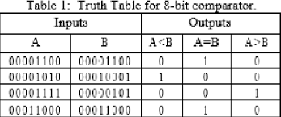

|  |
| --- |
| **Answer code** |
| module lab2_ex8(  input [17:0] SW,  output [17:0] LEDR,  output [7:0] LEDG  );  assign LEDR = SW;  parameter N = 8;  compNbit DUT (  .A(SW[N-1:0]),  .B(SW[N*2-1:N]),  .eq(LEDG[0]),  .gt(LEDG[1]),  .lt(LEDG[2])  );  defparam DUT.N = N;  endmodule  module compNbit #(  parameter N = 8  )(  input [N-1:0] A,  input [N-1:0] B,  output eq,  output gt,  output lt  );  assign eq = (A == B);  assign gt = (A > B);  assign lt = (A < B);  endmodule |
| **Testbench** |
| module compNbit_testbench;  reg [7:0] SW;  wire [7:0] LEDR;  wire [2:0] LEDG;  compNbit DUT (  .SW(SW),  .LEDR(LEDR),  .LEDG(LEDG)  );  initial begin  $monitor("Time = %0d | SW = %b | LEDR = %b | LEDG = %b", $time, SW, LEDR, LEDG);  SW = 8'b00000000; #10;  SW = 8'b10000000; #10;  SW = 8'b11111111; #10;  SW = 8'b01111111; #10;  SW = 8'b01010101; #10;  $finish;  end  endmodule |
|  |
| ss |